- The Monetary Policy Committee voted to keep Bank Rate at 5.25% at its meeting this week. Following a sea change in the outlook since its November meeting, the MPC cut its inflation forecast significantly. This led the MPC to suggest the debate has now shifted from whether more rate hikes were needed to how long the current policy stance needs to be maintained.
- The committee still stressed that it would like to see further evidence of an easing in core inflation and pay growth before cutting Bank Rate. Meanwhile, the MPC's forecast was consistent with a slightly less aggressive pace of loosening than market pricing implies. We now lean towards June for the first rate cut and assume 75bps of cuts this year.
The inflation outlook has improved significantly since November's Monetary Policy Report. Going into this week, we expected the Bank of England's Monetary Policy Committee to make substantial revisions to its inflation forecast in February's MPR and to remove its tightening bias. This proved to be the case.
The MPC voted to keep Bank Rate unchanged at 5.25% for the fourth consecutive meeting. The vote was split three ways, with Catherine Mann and Jonathan Haskel continuing to vote for a rate rise to reduce the risk that high inflation becomes embedded. Swati Dhingra voted for a 25bps cut on the basis that cooling price pressures and demand warranted less restrictive policy settings.
The MPC lowered their near-term inflation forecast markedly in response to the recent shift in the inflation environment, which brought its forecast much closer to our current projection (Chart 1). This led the committee to remove its bias towards further tightening and for Governor Andrew Bailey to highlight that the key question now is how long Bank Rate would need to be held at its current level before being cut.
Chart 1: The BoE now expects inflation to return to its 2% target by May
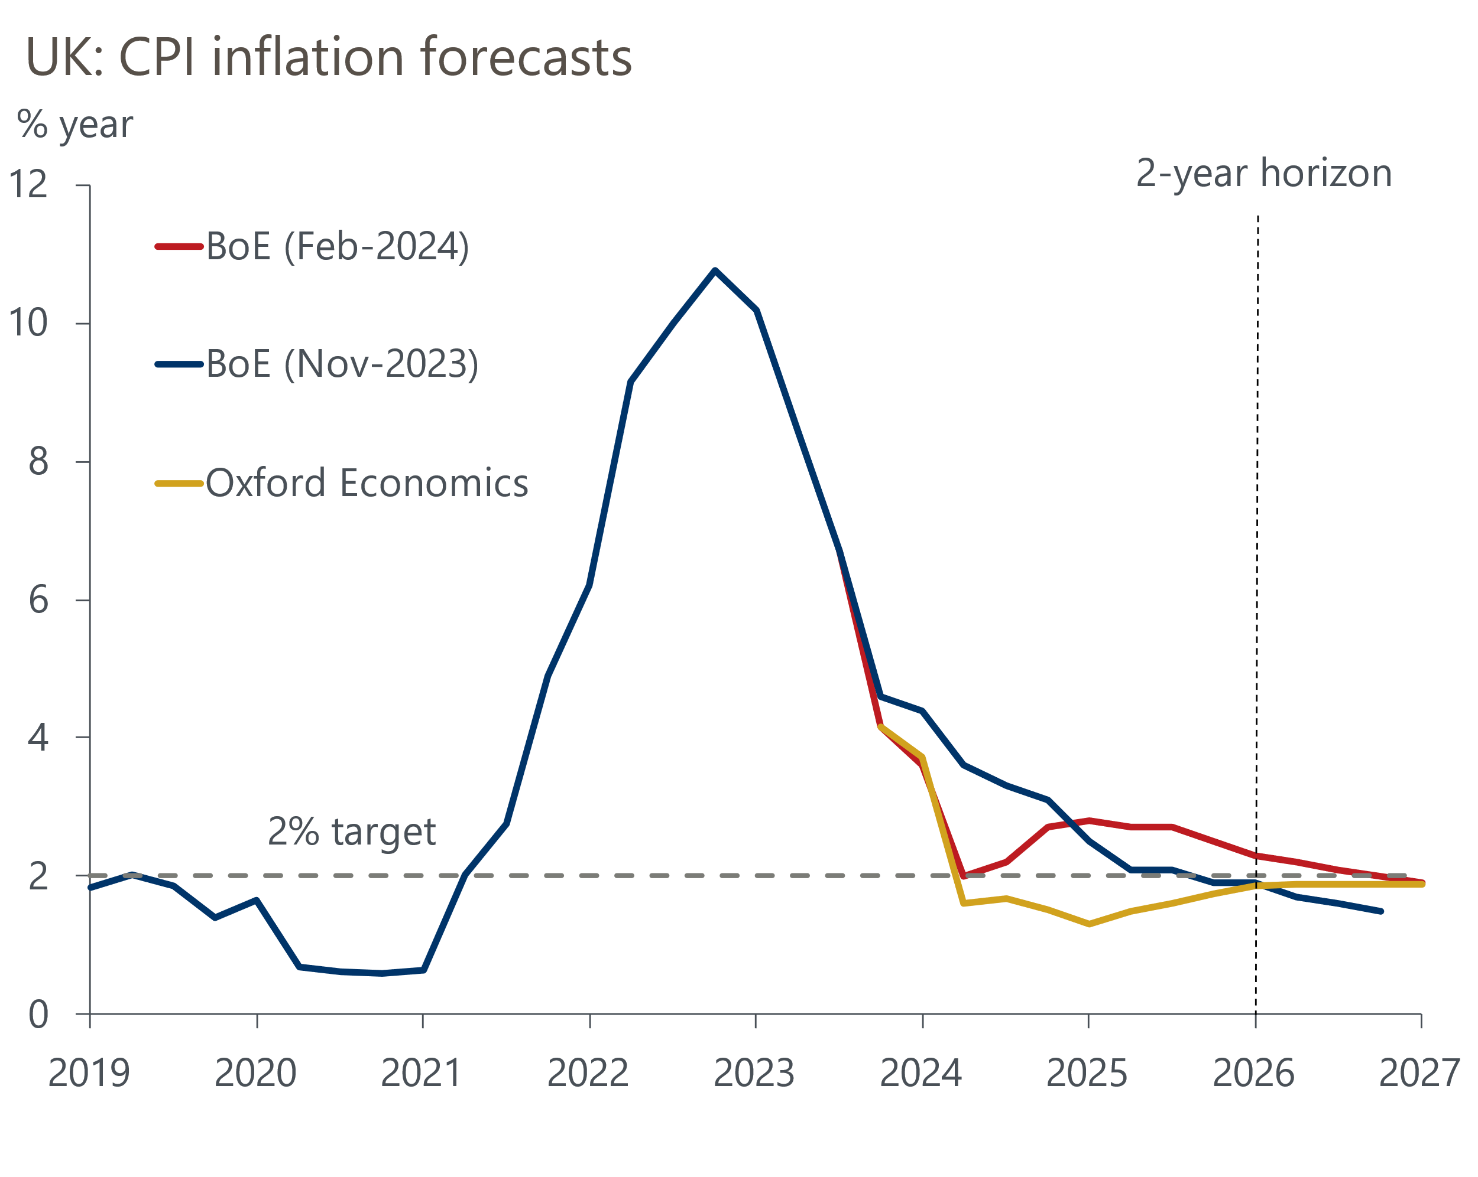
Source: Oxford Economics, Bank of England Monetary Policy Report

Still, the MPC were keen to emphasise that while headline inflation was now expected to fall back more quickly in the near term, core pressures were likely to prove stickier. Indeed, while the recent easing of official pay growth was welcomed, the results of the annual pay survey carried out by the BoE's regional agents found that the average settlement in 2024 was expected to be only slightly lower than the 2023 level. This is likely to play into the MPC's fears that wage growth will continue to run at a pace some way above the level that would be consistent with achieving the inflation target over the medium term.
The committee judged that the risks around its new inflation forecast were skewed to the upside in the near-term. This reflects geopolitical factors, in particular uncertainty around the impact that disruption to shipping through the Red Sea will have on core goods prices. January's final S&P Global/CIPS manufacturing survey suggested costlier ocean freight rates are already pushing up input cost inflation.
But crucially, the MPC judged that the risks from domestic price and wage pressures are now more balanced. This was part of a marked change of tone that opens the prospect of Bank Rate being cut significantly this year. For the first time, the Governor explicitly acknowledged that even if the MPC lowered rates, policy would remain restrictive. Furthermore, the BoE's inflation projection based on market rate expectations – which implied around 100bps worth of rate cuts this year – showed CPI inflation slightly above the 2% target in the medium term, while its constant rates projection had inflation sinking well below the target over the same time horizon. This implies the MPC expects to lower interest rates significantly, if not quite as aggressively as markets predict.
The MPC also took a more optimistic view of potential supply in its annual stocktake of the economy's supply side. This suggests the Bank is more confident the economy can cope with stronger demand without raising price pressures, so there's less need to maintain a restrictive policy stance.
The evolution of core inflation and pay growth will be central to the timing of the first rate cut and the pace of subsequent loosening. Given the stronger signal from the agents' pay survey, we think the MPC will seek more evidence that these pressures are abating before cutting. So while the May meeting remains a possibility for the first cut, June now looks like a stronger prospect as it gives the MPC two further pay and inflation releases. Sticky pay growth and uncertainty about the inflationary impact of events in the Red Sea also point to slower loosening. We now assume 75bps of rate cuts this year (previously 100bps).
Much of the recent good news in the housing market has been driven by lower interest rate expectations, which have pushed down mortgage rates. This week's BoE Money and Credit release reported that cheaper mortgage deals underpinned a steady recovery in mortgage approvals at the end of last year (Chart 2). But if – as we expect – monetary policy is loosened more slowly than markets expect, mortgage rates could edge up again. So the recovery in mortgage approvals is likely to remain slow.
Chart 2: Mortgage approvals rose slightly in December but remained well below long-run levels
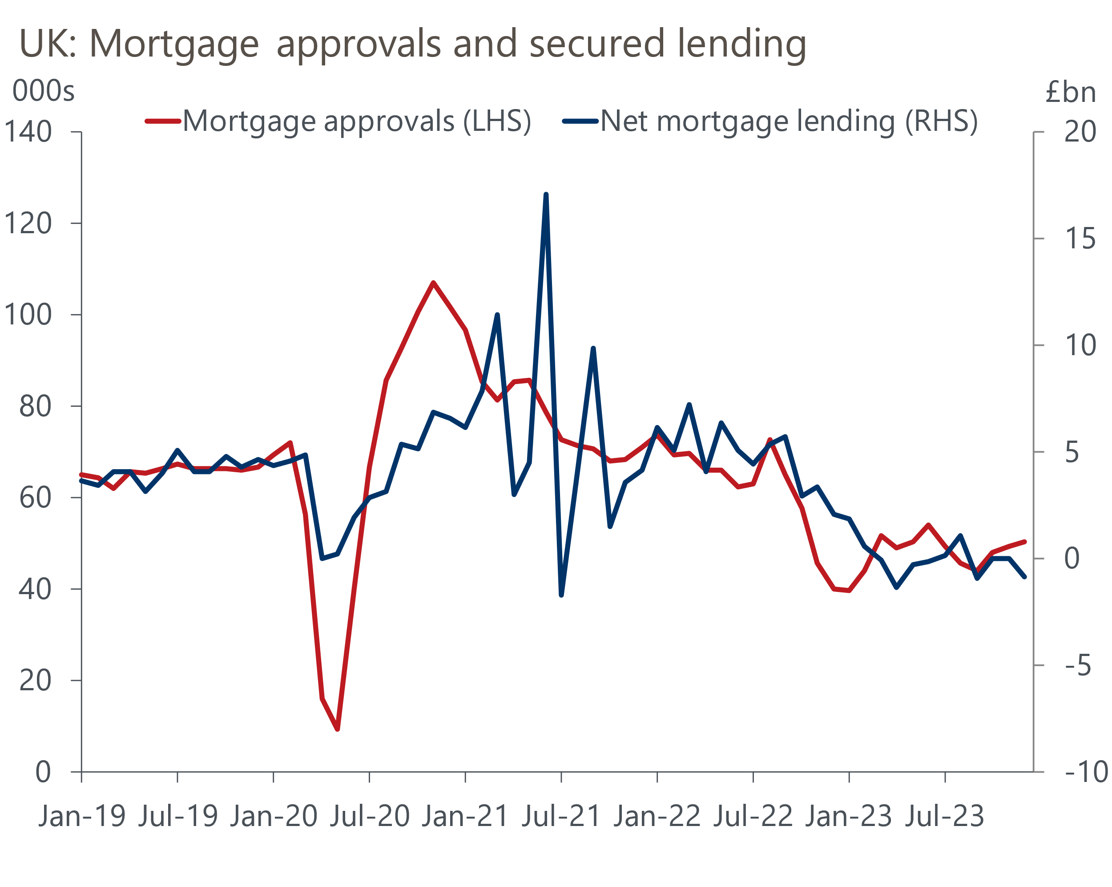
Source: Oxford Economics, Haver Analytics

The week ahead
January's final S&P Global/CIPS services survey is next week's sole release of note. The month's earlier flash survey reported a further broad-based increase in services activity, with the sector's PMI index rising to an eight-month high of 53.8. We see little reason to think the final PMI will shift significantly, so expect a final services PMI of 53.8. This would leave the composite PMI at around 52.5.
Table 1: Week ahead calendar
Date | Events | Period | Measure | Unit | Previous | Forecast
Feb 5 | S&P Global/CIPS services | Jan | PMI | % bal | 53.8 | 53.8
Feb 5 | S&P Global/CIPS composite | Jan | PMI | % bal | 52.5 | 52.5
Feb 6 | S&P Global/CIPS construction | Jan | PMI | % bal | 46.8 | 47.4
Source: Oxford Economics

Key forecasts
Table 2: UK forecast overview
(Annual percentage changes unless specified)
 | 2021 | 2022 | 2023 | 2024 | 2025 | 2026
GDP | 8.7 | 4.3 | 0.3 | 0.6 | 1.6 | 1.9
Private consumption | 7.5 | 4.8 | 0.6 | 0.9 | 1.8 | 1.9
Fixed investment | 7.4 | 8.0 | 2.3 | -3.2 | 0.5 | 2.8
Government consumption | 14.9 | 2.3 | 0.6 | 4.3 | 2.1 | 1.6
Exports of goods and services | 4.9 | 9.0 | -0.3 | 0.1 | 2.8 | 2.4
Imports of goods and services | 6.1 | 14.6 | -1.3 | 2.0 | 3.3 | 3.0
Industrial Production | -3.9 | -3.5 | -0.4 | 0.4 | 0.9 | 1.5
Consumer prices | 2.6 | 9.1 | 7.3 | 2.1 | 1.5 | 1.9
Unemployment rate (%) | 4.5 | 3.7 | 4.1 | 4.5 | 4.3 | 4.0
Current a/c balance (% of GDP) | -0.5 | -3.1 | -2.6 | -2.5 | -2.6 | -2.7
Government balance (% of GDP) | 7.2 | 4.4 | 5.2 | 3.2 | 2.8 | 2.4
Cen. bank policy rate (%, EOP) | 0.25 | 3.50 | 5.25 | 4.50 | 3.50 | 2.50
10yr govt. bond yield (%, EOP) | 0.97 | 3.67 | 3.54 | 3.63 | 3.43 | 3.00
Exchange rate (US$ per £, EOP) | 1.35 | 1.20 | 1.27 | 1.27 | 1.29 | 1.32
Exchange rate (euro per £, EOP) | 1.19 | 1.13 | 1.15 | 1.17 | 1.16 | 1.15
Source: Oxford Economics
Table 3: Quarterly forecasts for the UK
 | 2023 |  |  |  | 2024
 | Q1 | Q2 | Q3 | Q4 | Q1 | Q2 | Q3 | Q4
GDP (% year) | 0.4 | 0.3 | 0.3 | 0.2 | 0.2 | 0.4 | 0.8 | 1.0
CPI inflation (% year) | 10.2 | 8.4 | 6.7 | 4.2 | 3.7 | 1.6 | 1.7 | 1.5
Bank Rate (%, EOP) | 4.25 | 5.00 | 5.25 | 5.25 | 5.25 | 5.00 | 4.75 | 4.50
10yr gilt yield (%, EOP) | 3.47 | 4.39 | 4.46 | 3.54 | 3.75 | 3.65 | 3.65 | 3.63
US$ per £ (EOP) | 1.24 | 1.27 | 1.22 | 1.27 | 1.26 | 1.26 | 1.26 | 1.27
Euro per £ (EOP) | 1.14 | 1.17 | 1.15 | 1.15 | 1.17 | 1.17 | 1.17 | 1.17
Source: Oxford Economics

Latest Country Economic Forecast:
January 18, 2024

Recent publications

Data Insights
Red sea disruption raises manufacturing input costs
Mortgage activity picked up modestly in December
Flash PMIs suggest economy began 2024 on a better footing
December's fiscal deficit was well below expectations
Don't read too much into December's retail sales data

Research Briefings
BoE suggests rate cuts are coming…but not quite yet
Housing market on course for a soft landing
MPC preview – A change of tone, but not of policy
Nowcast points to continued labour market resilience
Will the MPC cut fast or slow?

Contacts

Oxford Economics' UK team
- Andrew Goodwin - Chief UK Economist - agoodwin@oxfordeconomics.com
- Edward Allenby - UK Economist - eallenby@oxfordeconomics.com

